Local or Global Optimization for Non-obtuse Remeshing

1. Local Method
In the original paper, a local method is used: at each step only one vertex is moved, the other vertices are fixed. Then the feasible region is defined by linear constraints as the followed figure.
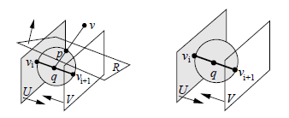

2. Global Method
If we want to solve the optimization globally, i.e., move all the vertices at each step, then we should constrain each vertex to be non-obtuse. For example, the constraint on the angle at vertex v₁ at the followed figure is dot(V₁V₃, V₁V₂) ≥ 0,
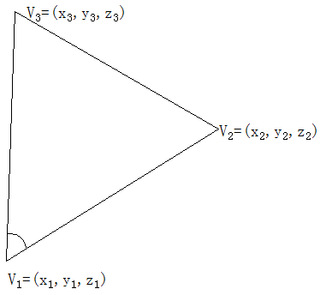
i.e.,
(x₃ – x₁) * (x₂ – x₁) + (y₃ – y₁) * (y₂ – y₁) + (z₃ – z₁) * (z₂ – z₁) ≥ 0. (1)

Then the optimization problem becomes a large-scale quadric optimization with quadric constraints with n variables and m constraints, where n and m are the numbers of vertices and angles. As we know, this optimization problem is difficult to solve. I had tested these non-obtuse constraints on the Nlopt solver, where the energy is the Laplacian energy. Except for the very small model, like cube(8 vertices, 12 facets), almost the models are failed, out of memory or very slow(cannot compute over a night for a modal with hundreds vertices).
Future directions:
1. Find new non-linear constraints optimization solver.
2. We also solve the optimization locally, but change the optimization energy.

